Chapter 9

Fractions mixed numbers and operations
Learn the ideas below, follow each worked example, then attempt the practice before checking the answers.

9.1 Fractions and their types
A fraction represents division or equal parts of a whole. The denominator tells the number of equal parts and must be nonzero. The numerator tells how many parts are counted. A positive proper fraction has numerator smaller than denominator; an improper fraction has numerator at least as large.
Worked example 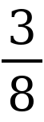 means three of eight equal parts. 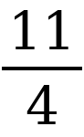 is improper and equals 2 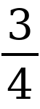, since 11 ÷ 4 = 2 remainder 3. Convert back using 2 × 4 + 3 = 11.

9.2 Equivalent fractions and simplest form
Multiply or divide numerator and denominator by the same nonzero number to preserve a fraction. To simplify fully, divide both by their HCF. Equivalent fractions represent the same point on a number line. Compare fractions by giving them a common positive denominator.
Worked example 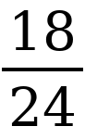 = after dividing both parts by 6. Also, 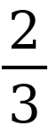 = 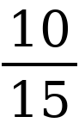 and 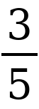 = 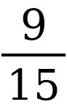, so > .

9.3 Adding and subtracting fractions
Equal denominators describe the same size of part, so add or subtract numerators and keep the denominator. For different denominators, first find equivalent fractions with a common denominator, preferably the LCM. Simplify the final answer. Convert mixed numbers to improper fractions when helpful.
Worked example 2 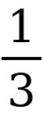 − = 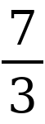 − = 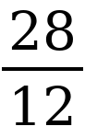 − 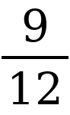 = 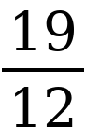 = 1 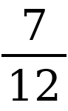. Never add the denominators.

9.4 Multiplying fractions and finding a fraction of an amount
Multiply numerators together and denominators together. Cancel common factors across the product before multiplying to keep the numbers small. Convert mixed numbers first. Finding a fraction of an amount means multiplying by that fraction.
Worked example 1 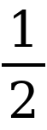 × 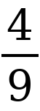 = 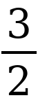 × = . Also, of 40 = × 40 = 24. Multiplication by a positive proper fraction reduces a positive amount.

9.5 Dividing fractions and reciprocals
The reciprocal of a nonzero number has product 1 with that number. To divide by a nonzero fraction, multiply by its reciprocal. Invert only the divisor. A whole number can be written over 1. Zero has no reciprocal and cannot be a divisor.
Worked example 2 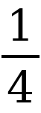 ÷ = 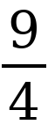 × 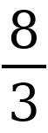 = 6. This asks how many groups of three eighths fit into two and one quarter.

9.6 Mixed operations and word problems
Apply brackets and the usual operation hierarchy. Convert mixed numbers before products or quotients, and keep exact fractions until the end. In a word problem, identify the whole. A fraction of the remainder uses a new whole after the first action.
Worked example A tank holds 60 L. First is used, leaving 40 L. Then of the remainder is used: × 40 = 10 L. The final amount is 30 L, not 25 L.

Common mistake to avoid
Cancellation is allowed between factors in a product. You cannot cancel terms across addition or subtraction without first factoring the whole expression.

Chapter 9 practice
Work in your notebook. Show your method and include units where needed.
1. Simplify 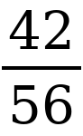.
2. Calculate 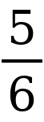 + .
3. Calculate 3 − 1 .
4. Calculate 1 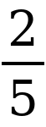 ÷ 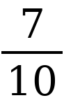.
5. A rope is 4 m long. Cut off of it. How much remains?

Answers with methods
1. Divide numerator and denominator by 14 to get .
2. 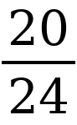 + 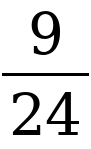 = 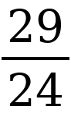 = 1 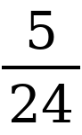.
3. 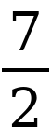 − 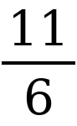 = 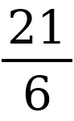 − = 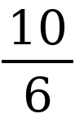 = 1 .
4. 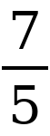 × 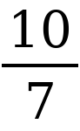 = 2.
5. The cut is × 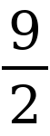 = 3 m. Remaining length is 4 − 3 = 1 m.

